*State Machine Diagrams for Each ECU*

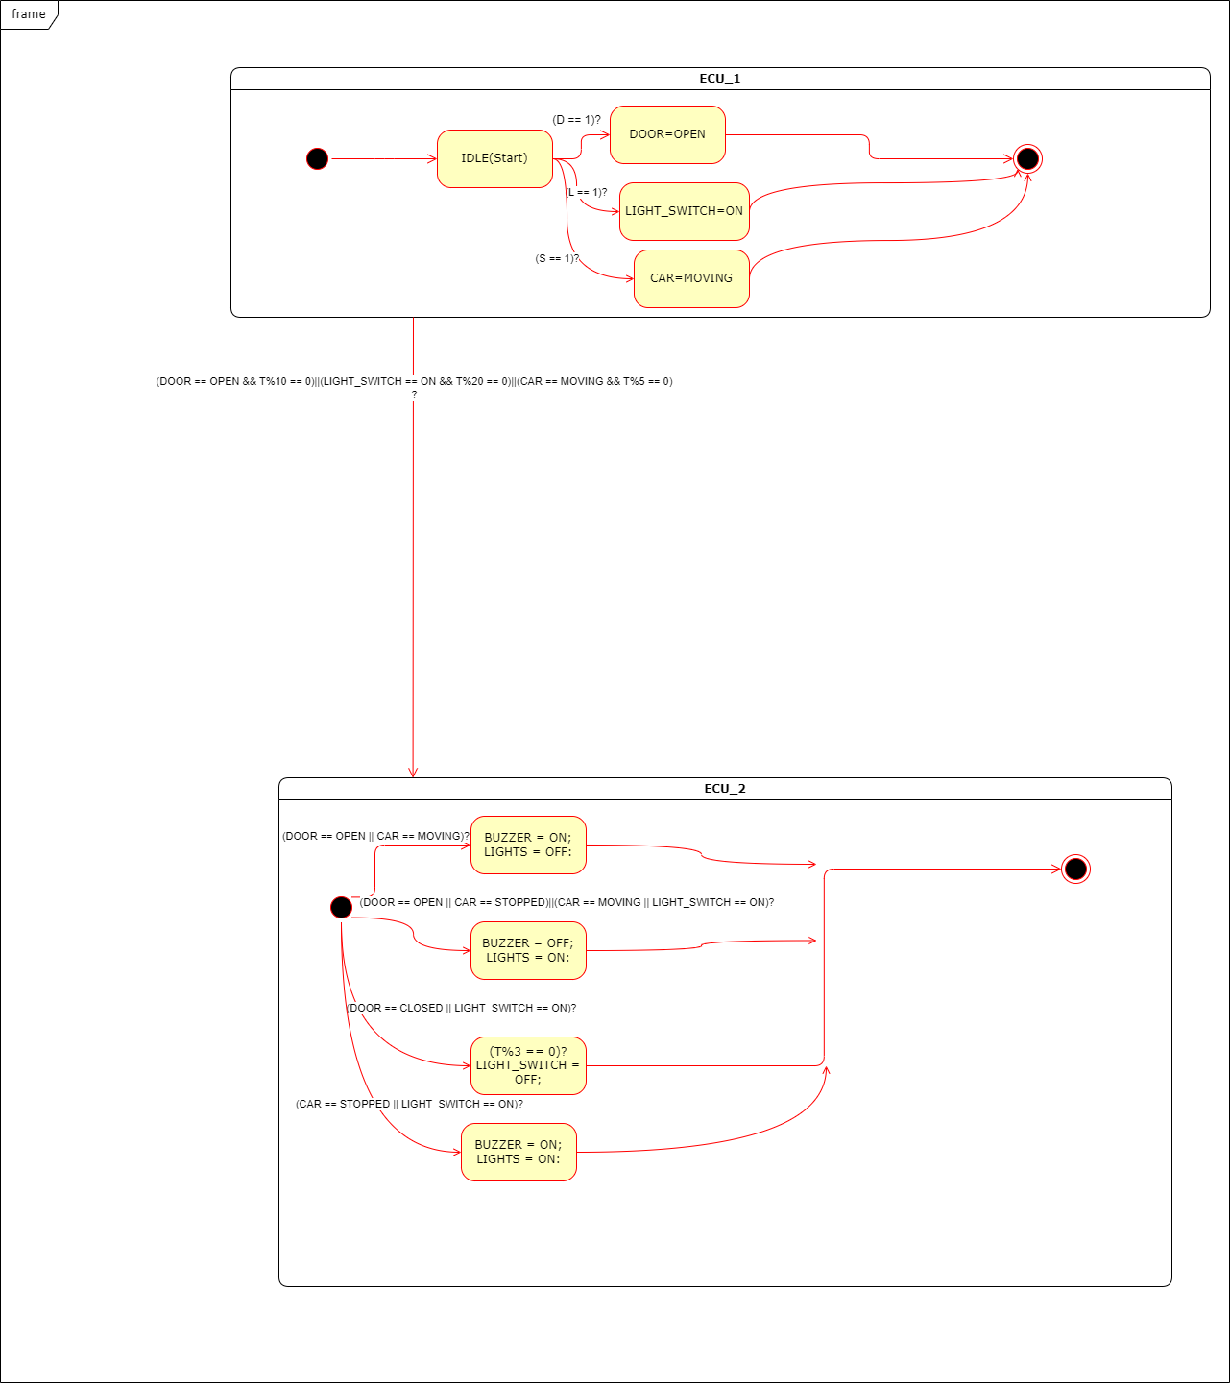

Figure (1) State machine for the whole System

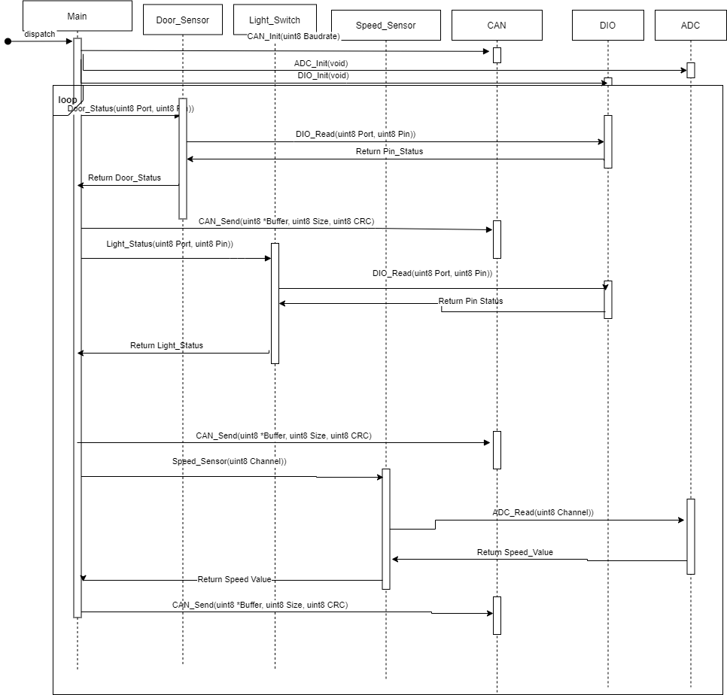

Figure (2) Sequence Diagram for ECU_1

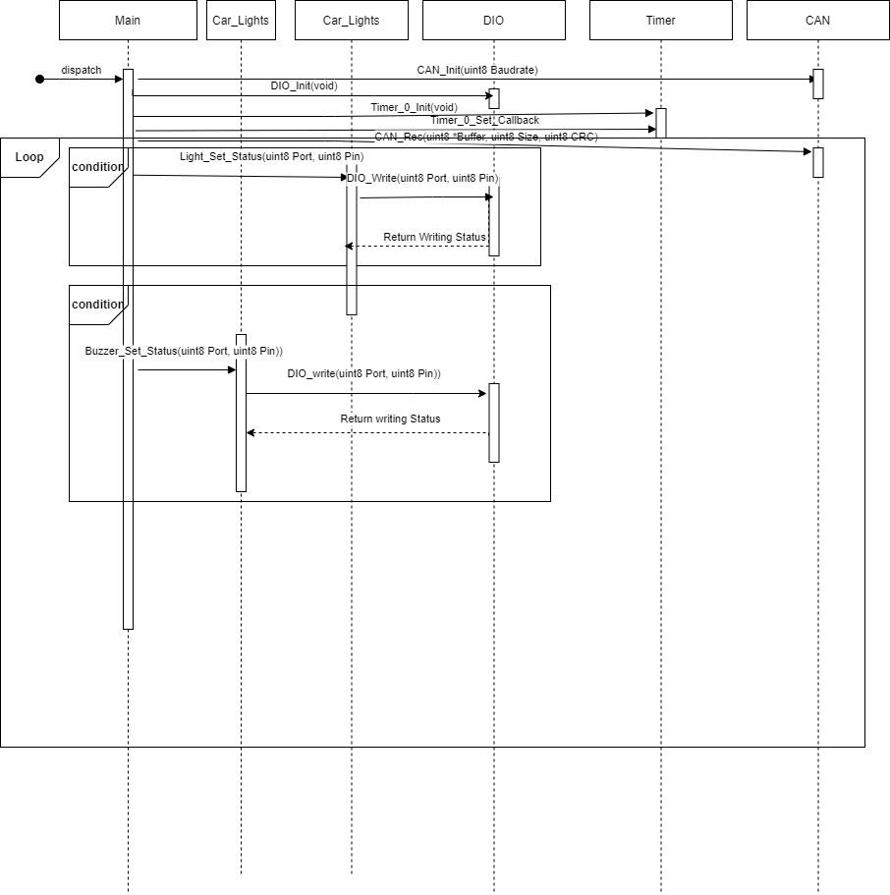

Figure (3) Sequence Diagram for ECU_2